Laboratory of Non-Equilibrium processes
of the Joint Institute for high temperatures Russian Acadeny of Sciences, is engaged in studying the kinetics of physical-chemical processes in high-temperature gases, combustion and detonation processes, and condensed particle formation.
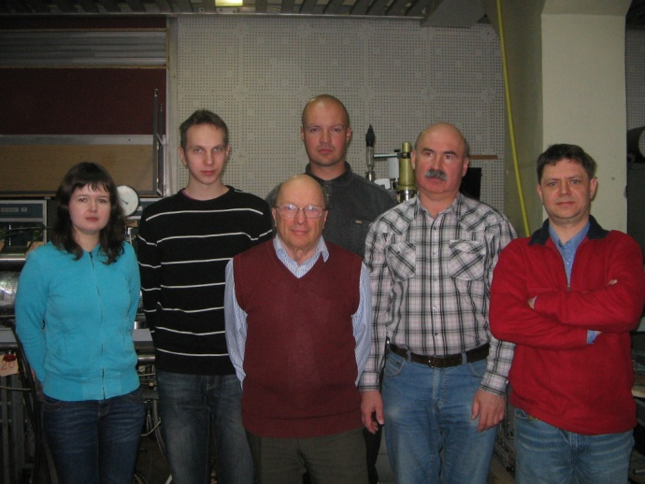

Personnel:
Prof. Alexander Eremin – Head of laboratory
Dr. Alexander Emelianov – Senior Researcher
Dr. Evgeny Gurentsov – Senior Researcher
Dr. Alexander Drakon – Researcher
Ekaterina Micheeva – PD. Student
Konstantin Priemchenko - PD. Student
Pavel Buchko – Student
Oleg Divakov – Engineer

Directions of investigations:
1.1. Kinetics of clusters and nanoparticles growth in pyrolysis and photolysis of gaseous species.
- heat release and consumption due to hydrocarbon pyrolysis and particle condensation;
- electrical charging of carbon particles during their growth;
- photosynthesis of nanoparticles;
- kinetics of carbon and iron clusters and nanoparticles growth;
- thermophysical properties of growing particles;
- development of time-resolved laser-induced incandescence for condensed particle-size and volume fraction measurements;

1.2. Non-equilibrium initiation of ignition and detonation behind shock waves.
- non-equilibrium processes in shock waves and gas-condensed media;
- detonation wave of condensation;
- ignition and detonation of perspective fuels behind shock waves;
- kinetics of promotion and inhibition of ignition and detonation.

Experimental setup
High vacuum shock tube for investigation of elementary reactions at elevated temperatures.
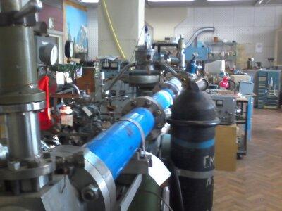

Shock tube for investigations of particle formation, ignition and detonation processes.
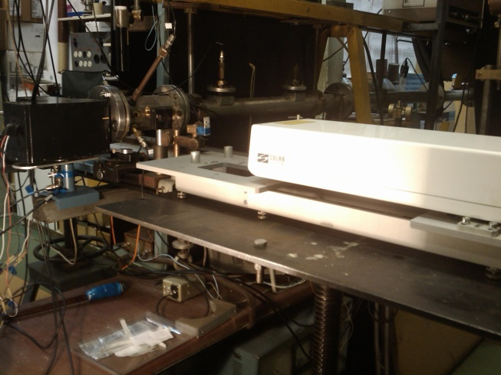

Flow reactor for photoinitiation of gaseous mixtures with quartz windows.
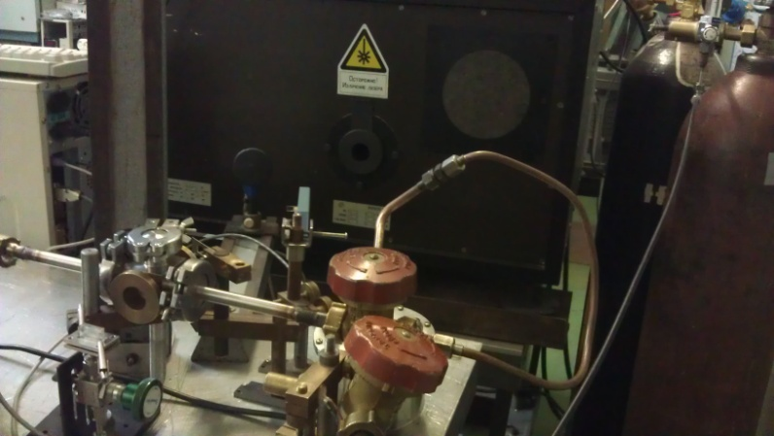

Experimental setup pressure range 0.001 bar - 1 bar (flow reactor) – 1 bar - 50 bar (shock tube)
Temperature range 300 K (flow reactor) – 600-5000 K (shock tube)
The range species concentration in the mixture 1 ppm – 10%.
Purity of gases – depends on experimental requirements (supply from Linde Gas Rus Ltd)

Diagnostics
- laser light extinction for volume fraction of condensed phase observation;
- laser-induced incandescence for nanoparticle sizing;
- emission-absorbtion temperature measurements;
- atomic and molecular absorption spectroscopy.
Equipment
- Nd:Yag pulsed laser (1064, 532, 266 nm; 0.5 J/pulse)
- Excimer laser (248 nm, 150 mJ/pulse)
- CW lasers, lamps, optics
- Photo diodes, photomultiplyers, laser energy monitors
- Pressure transducers up to 50 bar (Pfeiffer vacuum)

Some results
- The method of nanoparticle photosynthesis from the gas phase at room temperature was developed;
- The method of laser-induced incandescence was developed for growing carbon and iron nanoparticle sizing ;
- The influence of type and pressure of gas-diluter on carbon and iron nanoparticle growth process from supersuturated atomic vapor condensation was found and investigated;
- The thermal energy accommodation coefficients of gas molecules (He, Ar, CO) on carbon and iron nanoparticle surface were determined;
- The optical properties of carbon and iron nanoparticles were defined in dependence on their size;
- The ignition delays of products of water vapor of methane conversion were investigated theoretically and in experiment;
- The mechanisms of nonequilibrium processes in the mixtures contained reactive molecules were studied within shock wave front;
- The process of formation of detonation wave in supersaturated carbon vapor was found and investigated;
- The heat effects during pyrolysis and particle growth were investigated for the mixtures of СCl₄, C₂Cl₄, C₃O₂, C₂H₂, C₆H₆ with argon behind shock waves.

Selected publications
  - Deppe J., Emelianov A., Eremin A., Wagner H.Gg., Zaslonko I. Carbon particle formation and decay in two-step pyrolysis of carbon suboxide behind shock waves. Proc. of Comb. Institute, 2000 V.28 P. 2515-2522.
  - E.V. Gurentsov, О.G. Divakov, А.V. Eremin Ignition of multicomponent hydrocarbon-oxygen mixtures behind shock waves. High Temperature, 2002 V. 40(3) P.416-423.
  - Starke R ., Kock B., Roth P., Eremin A., Gurentsov E., Shumova V. and Ziborov V. Shock wave induced carbon particle formation from CCl₄ and C₃O₂ observed by laser extinction and by laser-induced incandescence (LII). Combustion and Flame. 2003 V.132 P.77-85.
  - Emelianov A., Eremin A., Gurentsov E., Makeich A., Jander H., Wagner H. Gg. Time and Temperature Dependence of Carbon Particle Growth in Various Shock Wave Pyrolysis Processes Proc. of the Combustion Institute, 2005 V. 30 P.1433-1440.

A.V. Eremin, E.V. Gurentsov, M. Hofmann, B.Kock, Ch. Schulz TR LII for sizing of carbon particle forming at room temperature. Appl. Phys.B, 2006 V.83 P.449-454.

A.V. Eremin, E.V. Gurentsov, M. Hofmann, B. Kock, Ch. Schulz. Nanoparticle formation from supersaturated carbon vapor generated by laser-photolysis of carbon suboxide. J. Phys. D: Appl. Phys. 2006 V.39 P.4359-4365.

A.V. Emelianov, A.V. Eremin, A.A. Makeich, H. Jander, H.Gg.Wagner, R. Starke, C. Schulz. Heat release of carbon particle formation from hydrogen free precursors behind shock waves. Proceedings of the Combustion Institute, 2007 V.31 P. 649-656.
  - Eremin A.V., Gurentsov E.V., Kock B., Schulz Ch. Influence of the bath gas on the condensation of supersaturated iron atom vapor at room temperature. Journal of Physics D, 2008 V.41 P.521-525.

Drakon, A. Emelianov, A. Eremin, Nonequilibrium radiation and ionization during formation of iron clusters in shock waves. J. Phys. D: Appl. Phys. 2008. V.41.

A. Emelianov, A. Eremin, V. Fortov, H. Jander, A. Makeich, and H. Gg. Wagner- Detonation wave driven by condensation of supersaturated carbon vapor. PHYSICAL REVIEW E. 2009 V. 79, 035303 (R).

A. Emelianov, A. Eremin Detonation wave initiated by explosive condensation of supersaturated carbon vapor. Shock Waves, 2010 V.20(6) P.491-498.

A. Emelianov, A. Eremin, H. Jander, H.Gg.Wagner. Carbon condensation wave in C₃O₂ and C₂H₂ initiated by a shock wave. Proceedings of the Combustion Institute, 2011 V. 33 P. 525-532.

Eremin A., Gurentsov E., Popova Е., Priemchenko K. Size dependence of refractive index function of small particles. Appl. Phys. B, 2011 V.104 P.285-295.

H. Böhm, A. Emelianov, A. Eremin, C. Schulz, H. Jander On the effect of molecular and hydrocarbon-bonded hydrogen on carbon particle formation in C₃O₂ pyrolysis behind shock waves. Combust. Flame, 2012, V. 159(3) P.932-939.

A.V. Eremin. Formation of carbon nanoparticles from the gas phase in shock wave pyrolysis processes. Progress in Energy and Combustion Science, 2012 V. 38(1) P.1-40.

